F: Mean Sequence

Input file: sequence.in
Output file: sequence.out
Balloon color: pink

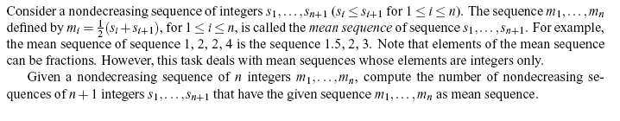

Task
Write a program that reads nondecreasing sequences of integers. For each sequence, your program must calculate and print the number of nondecreasing sequences for which the given sequence is a mean sequence. For example, there are four nondecreasing integer sequences for which 2, 5, 9 is a mean sequence. The sequences are: [2, 2, 8, 10], [1, 3, 7, 11], [0, 4, 6, 12], and [−1, 5, 5, 13].

Input
The first line contains an integer that indicates the number of test cases. Then, each test case begins with an integer n, where 0 < n <= 100. The next n lines contain the sequence m₁,…,m_{n}. Each value of m is an integer between 0 and 100,000.

Output
For each test case, output a single integer that indicates the number of nondecreasing integer sequences that have the input sequence as the mean sequence.

Sample Input
2
3 2 5 9
3 1 7 8

Sample Output
4
2

