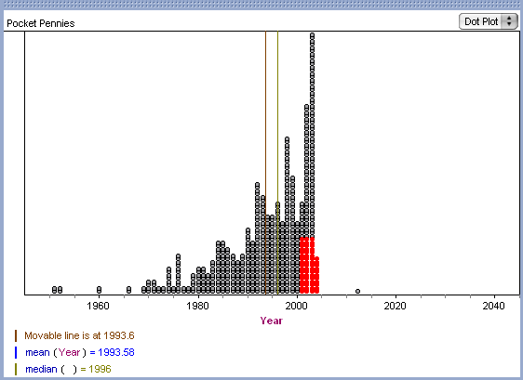
Here is an image of the graph of the data. I have created a movable line (brown) and placed it directly over the MEAN (blue). I have also plotted the MEDIAN (grey) I have also selected a group of data points that I will move to the right in the next image. Note: Fathom allows you to change data by dragging it in the graph. This is good to show the effect of different data values when teaching. In this diagram, the MEAN is to the LEFT of the MEDIAN, so the data is skewed LEFT.
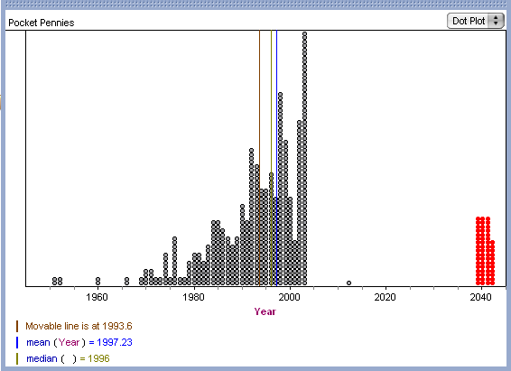
Notice that after I move the data points to the right, you can see that the blue mean line has also moved to the right of the MEDIAN. Extreme data to the right, causes the mean to change (skew) to the right.

